# Predicting Neighborhood Crime Activity Using FourSquare Venue Data

*Chris Robinson*

*January 2021*

## Introduction

### Background

Washington DC (DC) and New York City (NYC) are cities that offer a wide variety of local venues to satisfy the social, cultural, economic, spiritual, and day-to-day needs of its residents and visitors. As with most large cities, public safety is an ongoing challenge. Predicting patterns of criminal activity is key enabler for improving public safety. This study will make use of local venue data for DC and NYC neighborhoods to derive a feature that provides a measure of the heterogeneity of the neighborhood. I will test this feature as a predictor of criminal activity using both cluster analysis and regression analysis.

### Problem Statement

Predict patterns of local crime activity in large city neighborhoods based on statistics that measure the number and variety of local neighborhood venues. These predictions will be useful in improving public safety by informing the general public and public safety officials on how criminal activity is associated with the distribution of venues in a local neighborhood.

## Data acquisition and cleaning

### Data sources

Washington DC neighborhood labels and geographic position data are available for download in .CSV format from *Open Data DC* (https://opendata.dc.gov). The Washington DC government shares hundreds of datasets via this website.

Data on DC crime incidents was download from the DC Metropolitan Police Department website at <https://dcatlas.dcgis.dc.gov/crimecards/all:crimes/all:weapons/2:years/citywide:heat>. This data was also obtained in .CSV format.

NYC neighborhood location data was obtained from the “Segmenting and Clustering Neighborhoods in New York City” lab that is part of this IBM Data Science capstone course. The neighborhood dataframe was downloaded from the lab notebook as a .CSV file into my capstone project Git repository.

Data on NYC crime incidents for 2019 was downloaded from NYC Open Data website at <https://opendata.cityofnewyork.us/>. The data was accessed through the following API call *https://data.cityofnewyork.us/resource/8h9b-rp9u.csv?$where=arrest_date between '2019-01-01T00:00:00' and '2020-01-01T00:00:00'&$$app_token=3RN3HuHQhtXYNzT6OwDSVDKAK&$limit=1000000*

Data on local venues in the various DC and NYC neighborhoods will be obtained via API calls to FourSquare.com directly from the project Jupyter notebook.

### Data cleaning and preparation

Extraneous data in the raw .CSV files downloaded from DC and NYC government websites was removed using MS Excel. Some preliminary filtering of data was also done in Excel. The .CSV files were then saved with the partially cleaned data to the Git repository established for this project.

Additional cleaning will be done to convert date-time strings in the DC crime data to date-time objects. This will be done within the project Jupyter notebook using Python. This was necessary in order to filter on crime incidents that occurred in 2019. For the NYC crime incident data, the initial API call limited the response to only incidents that occurred in 2019. Python Pandas was used to extract only the columns needed for subsequent modeling, analysis and interaction with the FourSquare API.

FourSquare neighborhood venue data was downloaded and cleaned through reuse of the Python routines provided in the cluster analysis lab for the IBM™ *Applied Data Science Capstone* course. (See https://labs.cognitiveclass.ai/tools/jupyterlab/lab/tree/labs/DS0701EN/DS0701EN-3-3-2-Neighborhoods-New-York-py-v1.0.ipynb?lti=true)

### How data was used to address the problem statement

The analysis will use crime data for 2019. Though 2020 data is available and more recent, it will not be used since I assume there has likely been significant changes in crime patterns due to COVID-19 (testing this assumption would be an interesting follow on project).

The DC and NYC neighborhood location data will be used to retrieve venue data from FourSquare.com. The venue data will be used to generate the following features:

* Neighborhood venue count, venue category counts, and venue category frequencies
* Neighborhood venue entropy score – measures the diversity of an area as captured by the variety of venue categories within that area (see <https://www.cs.uic.edu/~urbcomp2013/urbcomp2016/papers/Exploring.pdf>)
* Neighborhood venue data will also be combined with neighborhood crime data for both cluster and regression analysis. For cluster analysis of the combined data, I will use DBSCAN clustering for its ability to identify outliers.

The DC and NYC crime data will be used to generate the following feature/label:

* Total number of criminal incidents reported in each location/neighborhood for 2019

To count the number of crime incidents for each neighborhood, I will use a Python function to loop through each neighborhood and count incidents within 500 meters of the neighborhood location using the respective crime incident data sets. Figures 1 and 2 below displays the header rows of the baseline data frame for Washington DC and New York City.

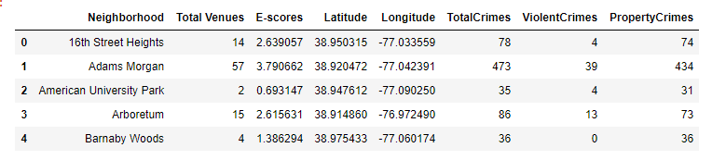

Figure 1 Washington DC 2019

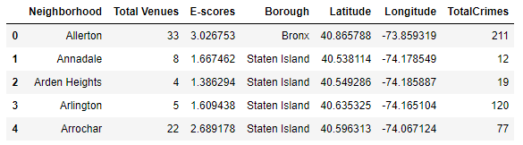

Figure 2 New York City 2019

I used multi-variate polynomial regression to construct models to predict annual neighborhood crime incidents using *neighborhood venue count* and *neighborhood venue entropy scores* as features. DC and NYC data were used to train and test the regression models. The various models will be evaluated using R2 scoring and comparing predicted distributions of crime incidents against actual distributions.

## Exploring the Data

### Relationship Between Neighborhood Venue Entropy and Total Annual Crimes

To better understand the relationship between crime and the variety and quantity of venues in a neighborhood location, I created the scatter plots below. These plots only look at total annual crime for 2019 versus neighborhood venue entropy score (*E-score*). Figure 3 shows a scatter plot for Washington DC and figure 4 for New York City. The plots indicate a rough non-linear relationship between crime totals for 2019 and the neighborhood *E-score*. Additionally, the scatter plot indicates that cluster patterns may exist.

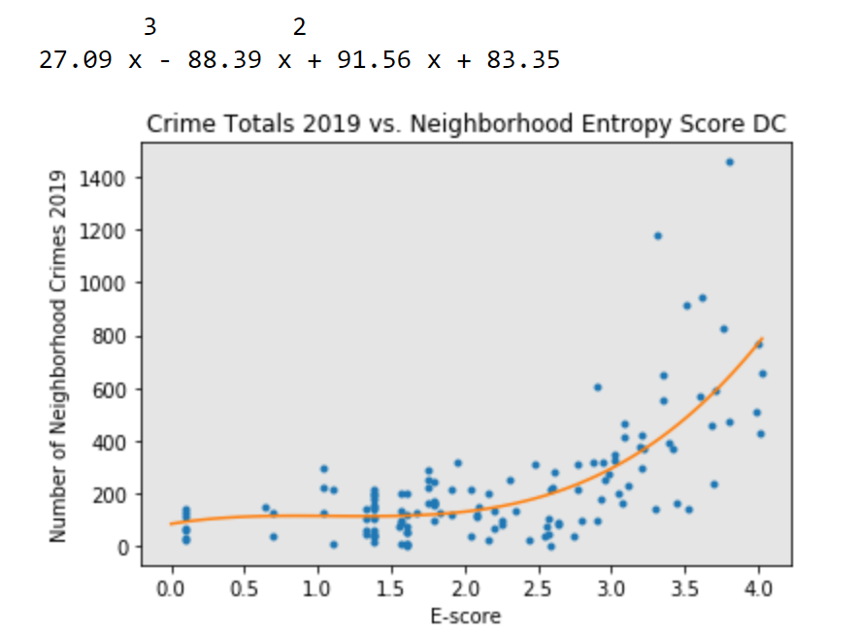

Figure 3 Exploring Relationship between Neighborhood Crime Totals and Venue Entropy Score - Washington DC

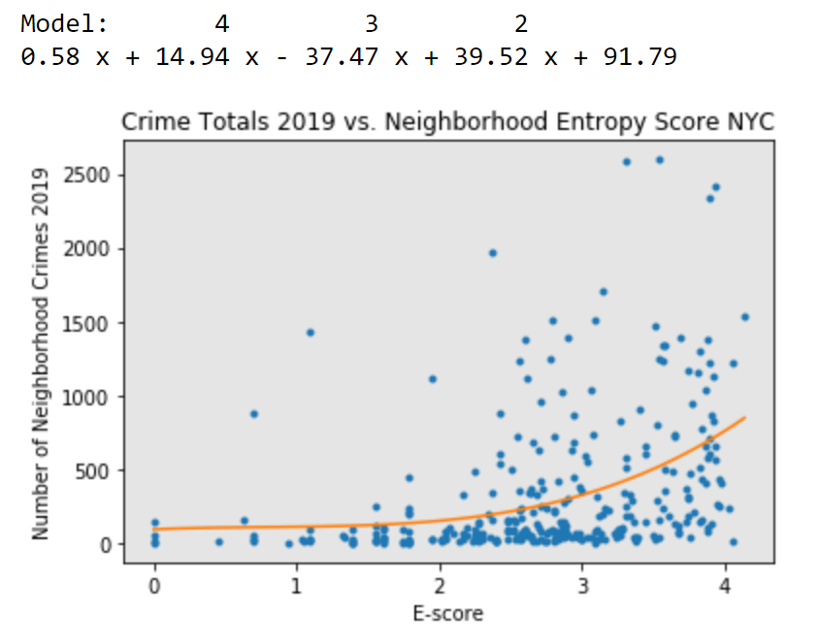

Figure 4 Exploring Relationship between Neighborhood Crime Totals and Venue Entropy Score – New York City

## Visualizing neighborhood crime patterns through density based cluster analysis

I used *Total Crimes*, *Total Neighborhood Venues*, and *Venue Entropy Score (E-score)* as features for a DBSCAN cluster analysis and then visualized clusters on a map to see how neighborhood crime patterns related to geographic location. The DBSCAN cluster analysis was evaluated using a silhouette score. Silhouette score is measure of the separation distance between the resulting clusters (see <https://scikit-learn.org/stable/modules/generated/sklearn.metrics.silhouette_score.html>). Through trial and error, I evaluated combinations of the DBSCAN parameters *eps* (search distance) and *min_samples* (minimum number of samples within search distance) to find the best clustering result around the feature set described above.

Figure 5 shows the results for New York City neighborhoods. The -1 label indicates outliers. One interpretation, considering Figure 6, is that in the outlier neighborhoods crime activity is less predictable based on *Total Venues* and *E-score.* And from the location pattern of outliers, these less predictable neighborhoods are more prevalent in vibrant, inner city locations such as Mid-town and lower Manhattan and the area of Washington DC extending from the National Mall to Georgetown and up to Dupont Circle (see figure 7).

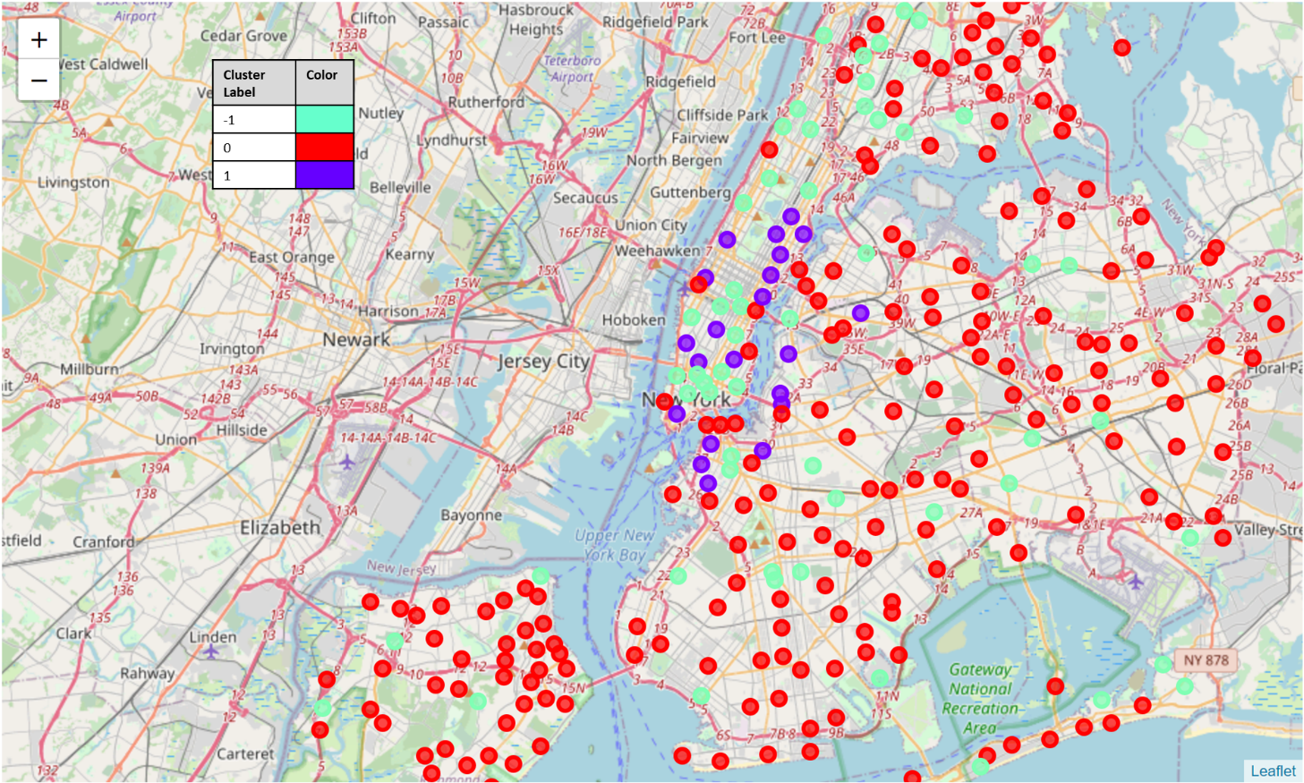

Figure 5 NYC Neighborhood Clusters Based on Venue Features and Annual Crime Totals

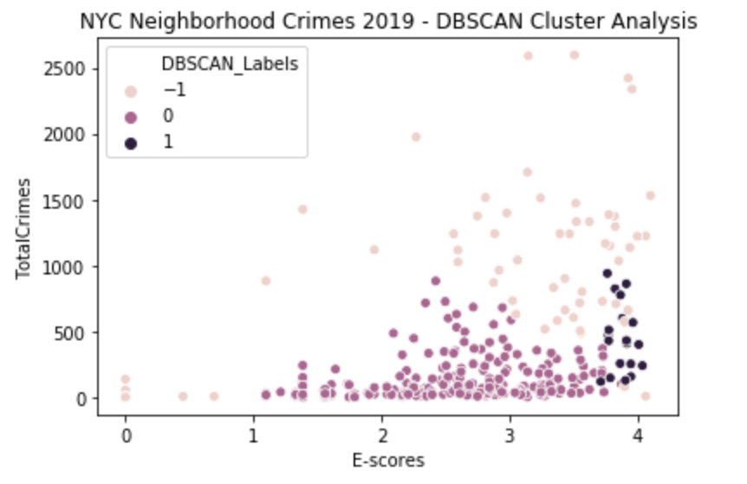

Figure 6 NYC Neighborhood DBSCAN Clusters - Total Crimes vs. E-scores Scatter Plot

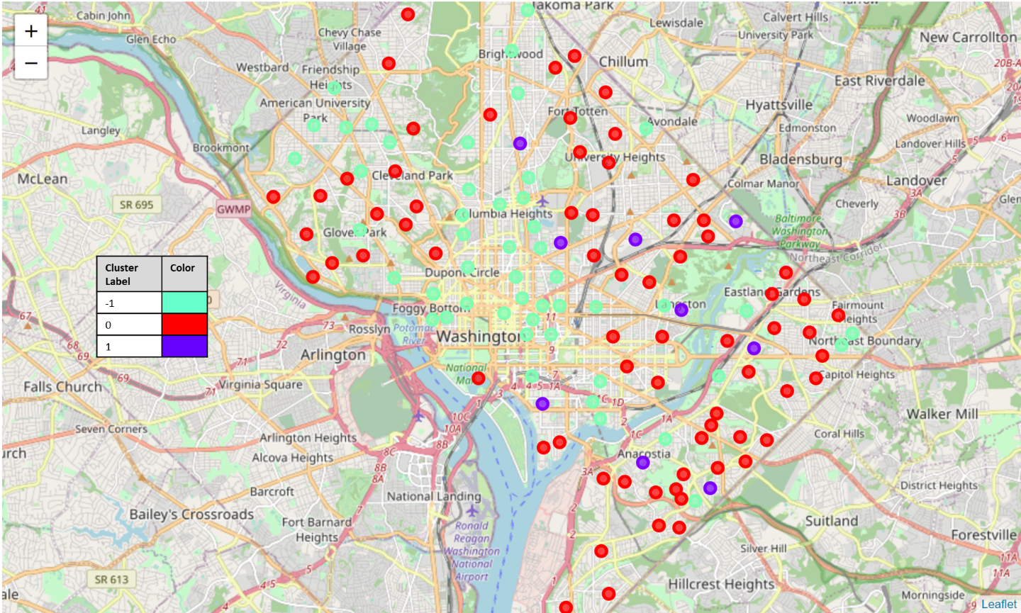

Figure 7 5 DC Neighborhood Clusters Based on Venue Features and Annual Crime Totals

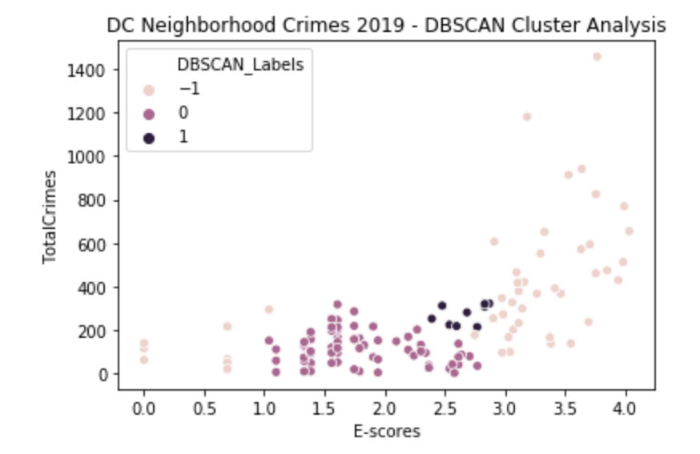

Figure 8 DC Neighborhood DBSCAN Clusters - Total Crimes vs. E-scores Scatter Plot

Both New York City and Washington DC show similar density-based clustering around the selected feature set (*Total Annual Neighborhood Crimes*, *Total Neighborhood Venue Count*, and *E-score*). This is show in the bar charts (figure 9) below as follows:

* -1 labeled outlier neighborhoods have high crime totals on average, with moderately high E-scores on average, but very high variability in E-scores.
* 0 labeled neighborhoods have very low average annual crime totals and moderate average E-scores with moderate variability. A large majority of neighborhoods are labeled this way in both NYC and DC.
* 1 labeled neighborhoods have moderately high crime totals on average with very high E-scores on average with low variability.

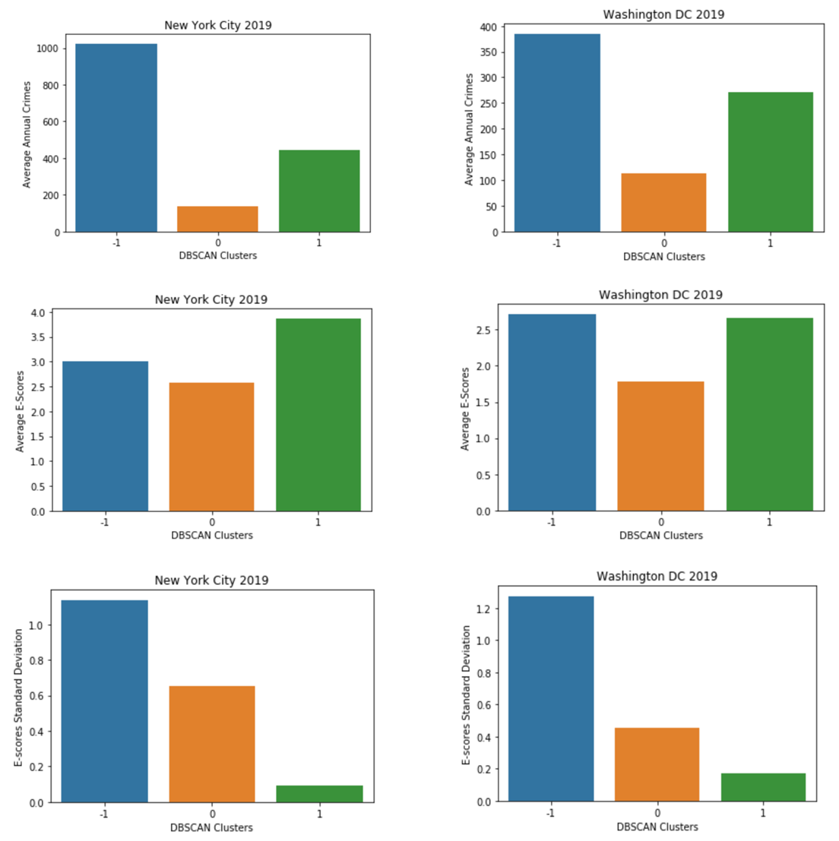

Figure 9 Analysis of Feature Statistics and Cluster Labels - NYC & DC Crime vs. Venue Characteristics

## Predictive Modeling

### Multi-variate Polynomial Regression with Cross-Validation

Next, I constructed a regression model to predict annual neighborhood crime totals using neighborhood *Total Venues* and *Venue Entropy Score (E-score)* as features. The regression model was evaluation using R2 score, cross-validation, and distribution plots of actual versus predicted annual neighborhood crime totals.

Figure 10 below shows the mean R2 results using model cross-validation for different degrees of the multi-variate polynomial fit. It is clear that the polynomial regression does not perform well with the given features.

### 

|  |  |  |
| --- | --- | --- |
| **Degree for Multi-Variate Polynomial Regression** | **Mean R2 Score from Cross-Validation** | |
| NYC Data | DC Data |
| 2 | 0.167 | 0.204 |
| 3 | 0.191 | -1.547 |
| 4 | 0.164 | -8.536 |
| 5 | 0.084 | -63.852 |

Figure 10 Cross-Validation R2 Scores for Polynomial Regression Fit to Predict Neighborhood Crime Totals

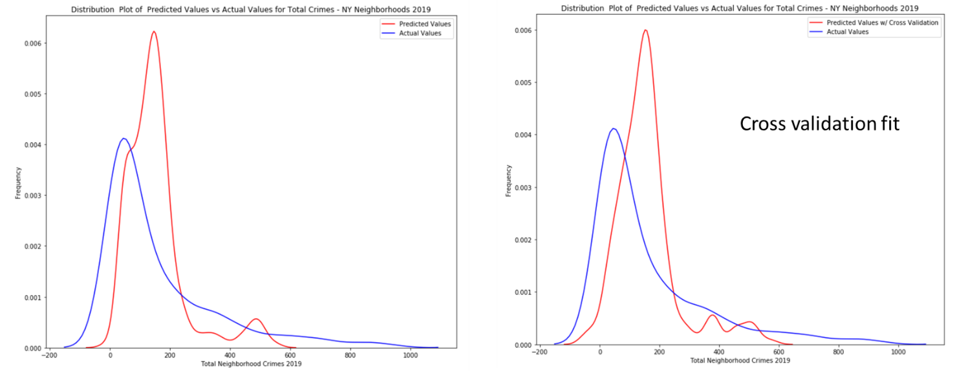

Figure 11 Distribution Plots of Actual vs. Predicted Neighborhood Crime Totals NYC

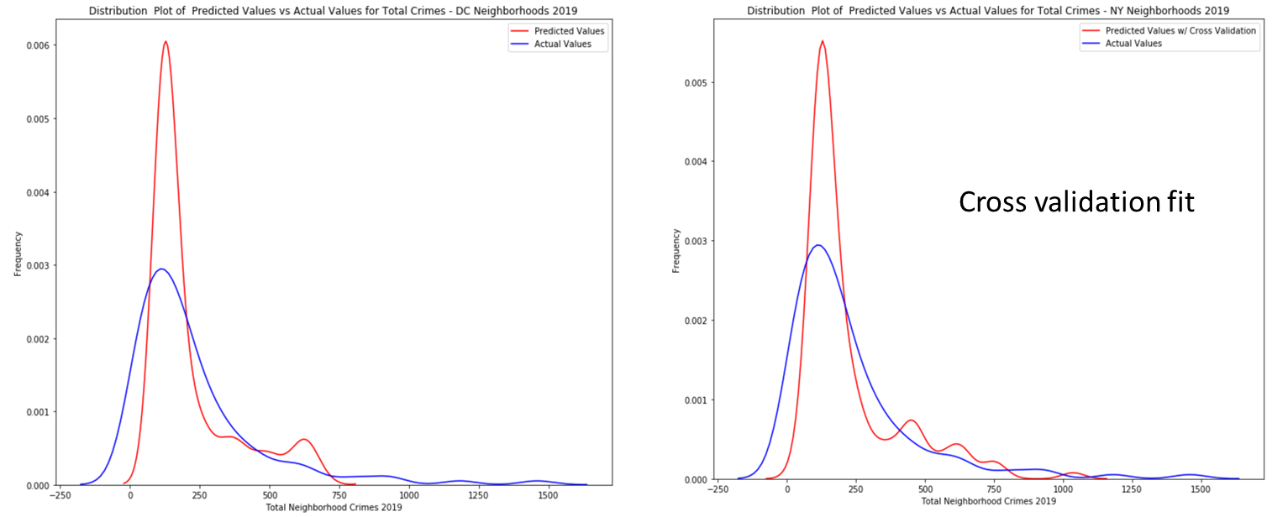

Figure 12 Distribution Plots of Actual vs. Predicted Neighborhood Crime Totals DC

## Conclusions